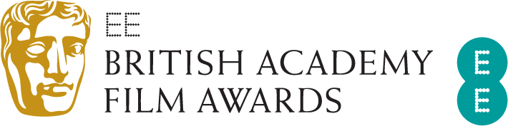
EE BRITISH ACADEMY FILM AWARDS:
WINNERS ANNOUNCED

Seven BAFTAs for 1917: Best Film, Outstanding British Film, Director,
Cinematography, Production Design, Sound and Special Visual Effects

Three BAFTAs for Joker: Leading Actor, Casting and Original Score
Two BAFTAs for Parasite: Film Not in the English Language and Original Screenplay
Renée Zellweger wins Leading Actress for Judy
Brad Pitt wins Supporting Actor for Once Upon a Time… in Hollywood
Laura Dern wins Supporting Actress for Marriage Story
Micheal Ward wins the EE Rising Star Award
London, Sunday 2 February 2020: At tonight’s EE British Academy Film Awards, 1917 won for Best Film, Outstanding British Film, with Sam Mendes receiving the BAFTA for Director and Roger Deakins taking Cinematography. 1917 also won for Production Design, Sound and Special Visual Effects.
Joker won three awards: Joaquin Phoenix won Leading Actor, Shayna Markowitz won the inaugural Casting award, and Hildur Guðnadóttir won Original Score.
Parasite won two awards: Original Screenplay for Bong Joon Ho and Han Jin Won and Film Not in the English Language.
Leading Actress was won by Renée Zellweger for Judy.
Supporting Actor went to Brad Pitt for Once Upon a Time… in Hollywood.
Laura Dern won Supporting Actress for Marriage Story.
For Sama, the epic and intimate journey filmed through five years of uprising in Aleppo, Syria, won Documentary.
Jojo Rabbit won Adapted Screenplay and Le Mans ‘66 took the BAFTA for Editing. Klaus took the award for Animated Film.
Bombshell received the BAFTA for Make Up & Hair, and Little Women won for Costume Design.
Writer/director Mark Jenkin and producers Kate Byers and Linn Waite received the award for Outstanding Debut by a British Writer, Director or Producer for Bait.
Learning to Skateboard in a Warzone (If You’re a Girl) won the British Short Film award, while the BAFTA for British Short Animation was won by Grandad Was a Romantic.
The Special Award for Outstanding British Contribution to Cinema was presented to Andy Serkis. Through his pioneering work in the evolving art of performance capture he has widened the parameters of what it means to be an actor in the 21st century.
The Fellowship, the highest honour the Academy can bestow, was presented to producer Kathleen Kennedy by HRH The Duke of Cambridge, President of BAFTA, and Daisy Ridley and John Boyega.
The EE Rising Star Award, voted for by the public, went to Micheal Ward.
The ceremony, hosted by Graham Norton, was held at London’s Royal Albert Hall and featured performances by Cirque du Soleil and Jessie Buckley.
As part of BAFTA’s year-round programme of learning events and initiatives, 50 of this year’s nominees took part in ‘BAFTA Film: The Sessions’ on Saturday 1 February at The Savoy Hotel. The Sessions saw the nominees discuss their craft in interviews that will be available online on BAFTA Guru soon.
Other year-round film activity includes initiatives such as our new talent activity and scholarships programme, BAFTA Crew, BAFTA Elevate, as well as masterclasses, the David Lean Lecture delivered by a leading film director, and the 'BAFTA A Life in Pictures' series.
To access the best creative minds in film, games and TV production, visit www.bafta.org/guru. For more, visit www.bafta.org.

For further information please contact Freuds:

Ebba Blakeborough-Tait
Ebba.Blakeborough-Tait@freuds.com
+44 (0) 203 003 6300

2 February 2020

