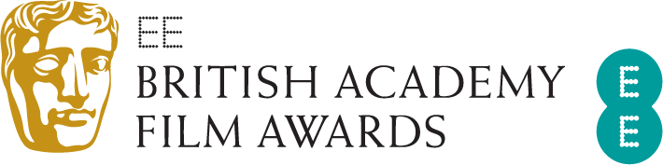

EE BRITISH ACADEMY FILM AWARDS IN 2021
WINS BY FILM/DISTRIBUTOR

BY FILM (14 films)

Another Round | 1 |  | My Octopus Teacher |  | 1
The Father | 2 |  | Nomadland |  | 4
His House | 1 |  | Promising Young Woman |  | 2
Judas and the Black Messiah | 1 |  | Rocks |  | 1
Ma Rainey’s Black Bottom | 2 |  | Soul |  | 2
Mank | 1 |  | Sound of Metal |  | 2
Minari | 1 |  | Tenet |  | 1
BY DISTRIBUTOR

Altitude (2) |  | Searchlight Pictures (4)
Minari | 1 | Nomadland |  |  | 4
Rocks | 1 | StudioCanal (1)
Disney (2) |  | Another Round |  |  | 1
Soul | 2 | Universal/Focus (2)
Lionsgate (2)  The Father |  | Promising Young Woman |  |  | 2
 | 2 | Vertigo / Amazon Studios (2)
Netflix (5) |  | Sound of Metal |  |  | 2
His House | 1 | Warner Bros (2)
Ma Rainey’s Black Bottom | 2 | Judas and the Black Messiah |  |  | 1
Mank | 1 | Tenet |  |  | 1
My Octopus Teacher | 1
EE BRITISH ACADEMY FILM AWARDS IN 2021

WINS BY FILM

Another Round (1)
Film Not in the English Language: Thomas Vinterberg, Kasper Dissing, Sisse Graum Jørgensen

The Father (2)
Adapted Screenplay: Christopher Hampton, Florian Zeller
Leading Actor: Anthony Hopkins

His House (1)
Outstanding Debut by a British Writer, Director or Producer: Remi Weekes (Writer/Director)

Judas and the Black Messiah (1)
Supporting Actor: Daniel Kaluuya

Ma Rainey’s Black Bottom (2)
Costume Design: Ann Roth
Make Up & Hair: Matiki Anoff, Larry M. Cherry, Sergio Lopez-Rivera, Mia Neal

Mank (1)
Production Design: Donald Graham Burt, Jan Pascale

Minari (1)
Supporting Actress: Yuh-Jung Youn

My Octopus Teacher (1)
Documentary: Pippa Ehrlich, James Reed, Craig Foster

Nomadland (4)
Best Film: Mollye Asher, Dan Janvey, Frances McDormand, Peter Spears, Chloé Zhao
Director: Chloé Zhao
Leading Actress: Frances McDormand
Cinematography: Joshua James Richards

Promising Young Woman (2)
Outstanding British Film: Emerald Fennell, Ben Browning, Ashley Fox, Josey McNamara
Original Screenplay: Emerald Fennell

Rocks (1)
Casting: Lucy Pardee

Soul (2)
Animated Film: Pete Docter, Dana Murray
Original Score: Jon Batiste, Trent Reznor, Atticus Ross

Sound of Metal (2)
Editing: Mikkel E.G. Nielsen
Sound: Jaime Baksht, Nicolas Becker, Phillip Bladh, Carlos Cortés, Michelle Couttolenc

Tenet (1)
Special Visual Effects: Scott Fisher, Andrew Jackson, Andrew Lockley

