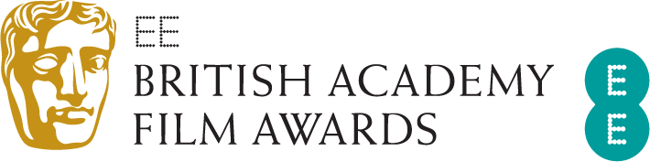
EE BRITISH ACADEMY FILM AWARDS:
WINNERS ANNOUNCED

Five BAFTAs for Three Billboards Outside Ebbing, Missouri:
Best Film, Outstanding British Film,
Leading Actress, Supporting Actor and Original Screenplay

Gary Oldman wins Leading Actor for Darkest Hour
Guillermo del Toro wins Director for The Shape of Water
Daniel Kaluuya wins the EE Rising Star Award

London, Sunday 18 February 2018: At tonight’s EE British Academy Film Awards Three Billboards Outside Ebbing, Missouri was named Best Film and Outstanding British Film, with Martin McDonagh winning Original Screenplay, Sam Rockwell taking Supporting Actor, and Frances McDormand receiving the BAFTA for Leading Actress.
Gary Oldman won Leading Actor for Darkest Hour; the film also won the award for Make Up & Hair.
The Shape of Water won three awards: Guillermo del Toro won for Director and composer Alexandre Desplat collected the Original Music award, his third BAFTA win; the film also won Production Design.
Supporting Actress went to Allison Janney for her role as Tonya Harding’s mother in I, Tonya.
Roger Deakins won his fourth BAFTA for Cinematography for Blade Runner 2049, which also won for Special Visual Effects.
Raoul Peck won the Documentary award for I Am Not Your Negro. Film Not in the English Language was won by South Korean drama The Handmaiden and Coco took the BAFTA for Animated Film.
Writer/director Rungano Nyoni and producer Emily Morgan received the award for Outstanding Debut by a British Writer, Director or Producer for I Am Not a Witch.
Baby Driver received the BAFTA for Editing and Phantom Thread won for Costume Design. James Ivory won for Adapted Screenplay for Call Me by Your Name and Dunkirk for Sound. Cowboy Dave won the British Short Film award.
The Special Award for Outstanding British Contribution to Cinema was presented to the National Film and Television School (NFTS). The school has trained generations of BAFTA-nominated film talent; this year’s British Short Animation award was won by Poles Apart, which is the 13th NFTS graduation film to win a BAFTA.
The Fellowship, the highest honour the Academy can bestow was presented to director and producer Sir Ridley Scott by HRH The Duke of Cambridge, President of BAFTA, and Sir Kenneth Branagh.
The EE Rising Star Award, voted for by the public went to Daniel Kaluuya.
The ceremony which was hosted for the first time by Joanna Lumley was held at London’s Royal Albert Hall, and featured performances by Cirque du Soleil and the Kanneh-Mason family.

As part of BAFTA’s year-round programme of events and initiatives, many of this year’s nominees took part in ‘BAFTA Film: The Sessions’ on Saturday 17 February. The Sessions saw the nominees discuss their craft in interviews that will be available online on BAFTA Guru in the coming weeks.
In addition, a number of the nominated short films are now available to view in Curzon cinemas around the country and online at https://www.curzonhomecinema.com/.
Other year-round film activity includes initiatives such as our new talent activity and scholarships programme, BAFTA Crew and BAFTA Elevate as well as masterclasses, the David Lean Lecture delivered by a leading film director and 'A Life in Pictures'.
To access the best creative minds in film, TV and games production, visit www.bafta.org/guru. For more, visit www.bafta.org.

For further information please contact Freuds:

Vicky Grayson
Vicky.grayson@freuds.com
+44 (0) 203 003 6327 / +44 (0) 7872 604 784

18 February 2018

