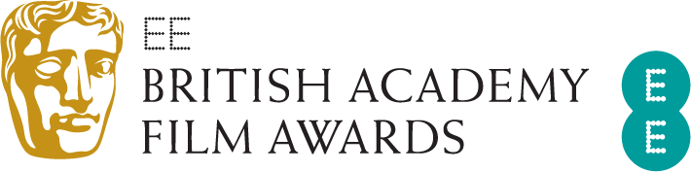
EE BRITISH ACADEMY FILM AWARDS:
WINNERS ANNOUNCED

Seven BAFTAs for The Favourite: Outstanding British Film,
Leading Actress, Supporting Actress, Original Screenplay,
Costume Design, Production Design, Make Up & Hair

Four BAFTAs for Roma: Best Film, Director, Film Not in the English Language and Cinematography
Rami Malek wins Leading Actor for Bohemian Rhapsody
Mahershala Ali wins Supporting Actor for Green Book
Letitia Wright wins the EE Rising Star Award

London, Sunday 10 February 2019: At tonight’s EE British Academy Film Awards, The Favourite was named Outstanding British Film, with Olivia Colman receiving the BAFTA for Leading Actress, Rachel Weisz taking Supporting Actress and Deborah Davis and Tony McNamara winning Original Screenplay. Sandy Powell won Costume Design, Fiona Crombie and Alice Felton won Production Design and Nadia Stacey won Make Up & Hair.
Roma won four awards: Best Film, Director, Cinematography and Film Not in the English Language. Alfonso Cuarón won in each of these categories.
Rami Malik won Leading Actor for his performance as Freddie Mercury in Bohemian Rhapsody; the film also won the award for Sound.
Supporting Actor went to Mahershala Ali for his performance in Green Book.
BlacKkKlansman won Adapted Screenplay. Spider-Man: Into the Spider-Verse took the award for Animated Film, and Documentary was won by Free Solo.
A Star Is Born won Original Music and Vice took the BAFTA for Editing. Black Panther received the BAFTA for Special Visual Effects.
Writer/Director Michael Pearce and Producer Lauren Dark received the award for Outstanding Debut by a British Writer, Director or Producer for Beast.
73 Cows won the British Short Film award, while the BAFTA for British Short Animation was won by Roughhouse.
The Special Award for Outstanding British Contribution to Cinema was presented to Elizabeth Karlsen and Stephen Woolley, a producing partnership who have created some of the most iconic British films of recent years, including The Crying Game, Company of Wolves, Little Voice, Scandal, Carol and Colette.
The Fellowship, the highest honour the Academy can bestow, was presented to editor Thelma Schoonmaker by HRH The Duke of Cambridge, President of BAFTA, and Cate Blanchett.
The EE Rising Star Award, voted for by the public, went to Letitia Wright.
The ceremony, which was hosted by Joanna Lumley, was held at London’s Royal Albert Hall and featured performances by Cirque du Soleil and Jess Gillam.

As part of BAFTA’s year-round programme of learning events and initiatives, over 80 of this year’s nominees took part in more than 14 ‘BAFTA Film: The Sessions’ on Saturday 9 February. The Sessions saw the nominees discuss their craft in interviews that will be available online on BAFTA Guru in the coming days.
In addition, the nominated short films are now available to view in Curzon cinemas around the country and online at www.curzonhomecinema.com.
Other year-round film activity includes initiatives such as our new talent activity and scholarships programme, BAFTA Crew and BAFTA Elevate as well as masterclasses, the David Lean Lecture delivered by a leading film director and 'A Life in Pictures'.
To access the best creative minds in film, games and TV production, visit www.bafta.org/guru. For more, visit www.bafta.org.

For further information please contact Freuds:

Vicky Grayson
vicky.grayson@freuds.com
+44 (0) 203 003 6327 / +44 (0) 7872 604 784

10 February 2019

